Algebra I
Unit 3A Test Stations Review
Station 1 – SLOPE/RATE OF CHANGE
EASY
HARD
- What is the slope of the line that passes through the
points (-5, 2) and (7, -4)?

- What is the slope of the line below?
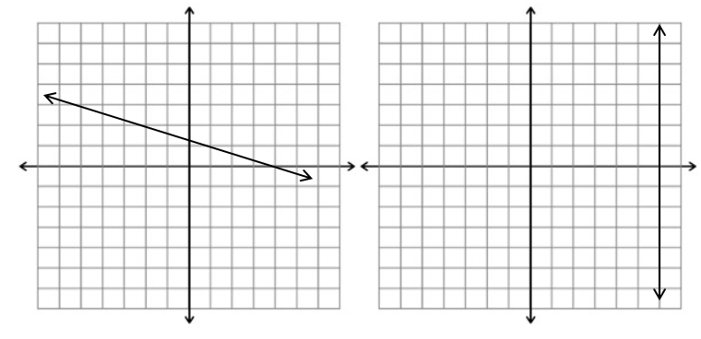
- B.

- What is the rate of change?
Number of pounds | Total Cost
4 | 6
6 | 9
8 | 12
10 | 15
12 | 18

- Determine whether the following scenarios describe a positive, negative, zero, or undefined slope:
- In the first quarter of the football game NVHS had 7 points. In the third quarter NVHS had 28 points.
- In January Sally weighed 160 pounds. In June, she weighed 140 pounds.
Algebra I
Unit 3A Test Stations Review
Station 2 – POINT-SLOPE
EASY
HARD
- Graph y + 2 = 3(x – 1)
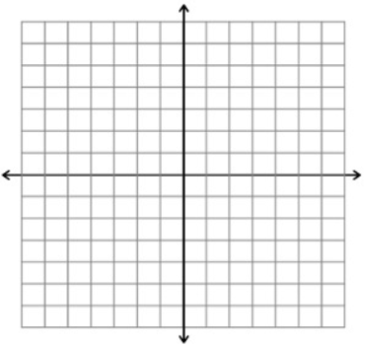

- Graph y – 4 = -2(x + 3)

- Create four flashcards, one for each of the formulas in unit 2.

Algebra I
Unit 3A Test Stations Review
Station 3 – SLOPE INTERCEPT
- Identify the slope and y-intercept of the equation y = -7x+1. Label both answers.
EASY
HARD

- Write the equation of the line with an intercept of -5 and a
slope of 4 in slope-intercept form.

- Graph the equation y = -1/2x – 3

- You have $350 in your bank account and spend $40 per week.
- In six weeks, how much will you have left in your account?

- Define two variables and write a linear equation to model the situation.

- Graph the equation that you wrote. Be sure to label your x and y axis and consider your units.

- How many weeks will it take for your account to have a zero balance?

Algebra I
Unit 3A Test Stations Review
Station 4 – STANDARD FORM & HORIZONTAL/VERTICAL LINES
EASY
HARD
- Graph the equation
- -5x + 2y = 10 B. -2x – 4y = -12

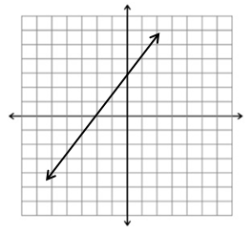
- What would the y-intercept be if the x-intercept moved
two units to the left?

- Graph the equations
A. x = -4 B. y = 5

- Write an equation of a vertical line.
Algebra I
Unit 3A Test Stations Review
Station 5 – COLLINEAR-PARALLEL-INTERSECTING
EASY
HARD
- Are the following points collinear? Explain your answer.
- (-1,-11) (2,7) (4,19) B. (-8,-1) (4,2) (8,5)

- Are the following linear representations parallel or intersecting? Explain.
a) b)
y = 2x - 4

Are the following linear representations parallel or intersecting?
x | y
-6 | 2
-3 | 0
0 | -2
3 | -4
6 | -6

y = -2/3x + 5

- Are the following linear equations parallel or intersecting?
y = 4x + 6 y – 3 = ¼ (x – 2)

Algebra I
Unit 3A Test Stations Review
Station 6 – APPLICATION
EASY
HARD
- Write an equation of a line that has a positive slope.

- Write an equation of a line that has a zero slope.
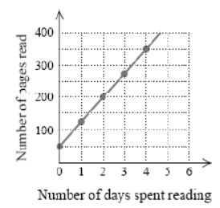

A. What is the rate of change and what does it mean in the context of this example?

- What is the y-intercept and what does it mean in the
context of this example?

- Write an equation that best models the graph.

