**Station 1**

Solutions:

1) -1/2

2) A. -1/3 B. undefined

3) $1.50/lb OR $3/2 pounds

4) A. Positive B. Negative

**SLOPE/RATE OF CHANGE**

**Station 2**

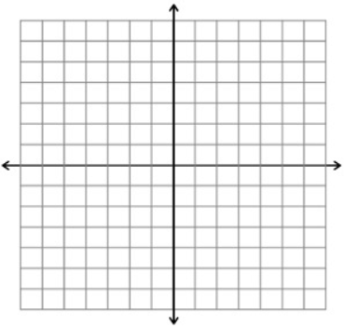Solutions:

1) 2)

3) SI: y=mx+b SF: Ax+By =C PS: y – y1=m(x-x1) SLOPE: 

**POINT-SLOPE**

**Station 3**

Solutions:

1) slope (m) = -7 y-intercept (b) = 1 OR (0,1) 3)

2) y = 4x - 5

4) A. $110

B. x = # of weeks y = account balance y = -40x + 350

C.

D. 9 weeks

**SLOPE INTERCEPT**

**Station 4**

Solutions:

1) A. B. 2) b = 6 OR (0, 6)

3) A. B. 4) x = #

**STANDARD FORM & HORIZONTAL/ VERTICAL LINES**

**Station 5**

**Station 5**

Solutions:

1) A. Yes, same slope (m = 6)

B. No, different slopes (m = ¼ and m = ¾ )

2) Perpendicular, opposite reciprocal slopes

3) Parallel, same slopes

4) Neither

**COLLINEAR-PARALLEL-INTERSECTING**

**Station 6**

Solutions:

1. y = 8x - 3

1. y = #
2. A. 75 pages/day

B. 50 pages, the person is starting to read on page 50.

C. y = 75x + 50

**APPLICATION**