Algebra 1 Name: _____________________________

Unit 3 Part A Review

**1. Write an equation for**:

a. a horizontal line: ____________ c. a line with negative slope: __________________

b. a vertical line: ____________ d. a line with positive slope: __________________

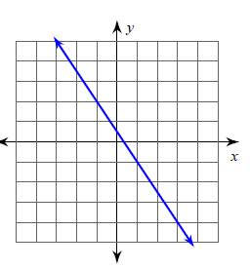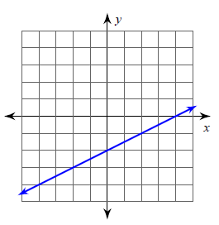

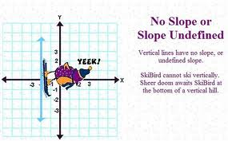**2. Identify the slope of the line.**

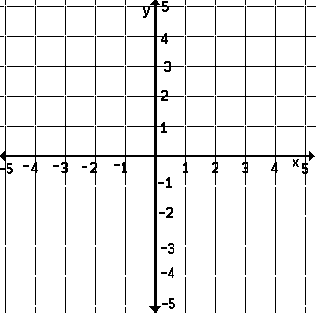

a. Slope: _______ b. Slope: _______ c. Slope: _______

**3. Find the slope of a line that has these points:**

a. (8, 2) and (11, 3) b. (8, 0) and (8, 6)

**4. Without graphing, tell whether the slope of a line that models the linear relationship is positive, negative, zero or undefined and find the average rate of change:**

a. Michael started a savings account with $800. After 4 weeks, he had $750 dollars, and after 10 weeks, he had $675. What is the rate of change of money in his savings account per week?

b. A plane left Chicago at 8:00 A.M. At 1:00 P.M. the plane landed in Los Angeles, which is 1500 miles away. What was the average speed of the plane for the trip?

5. **The data in the tables in consistent. Find the rate of change, including the correct units, and explain what the rate of change represents.**

|  |  |
| --- | --- |
| **Candy bars bought** | **Cost**  **(dollars)** |
| 5 | $3.75 |
| 17 | $12.75 |
| 24 | $18.00 |
| 27 | $20.25 |

|  |  |
| --- | --- |
| **Private**  **Lessons** | **Cost**  **(dollars)** |
| 3 | 45 |
| 5 | 75 |
| 8 | 120 |
| 13 | 195 |

a. Rate of change: b. Rate of change:

Explanation: Explanation:

6. **Identify the slope and y-intercept of the line:**

a)  m: _____ y-intercept: ______ b)  slope: _____ b: ______

7. **Write the equation of the line given the slope and y-intercept (y-int) and graph.**

a) m = - $\frac{2}{3}$ y-int = 3 Equation:_____________ b) m = 4    y-int = -3 Equation:______________

8. **Graph the following equations:**

a. 2x + 3y = 6 b. x = 4 c. y + 3 = (x – 1) d. y = -3

9. **Are the points collinear? Explain your answer.**

a. A(5, 3) B(0, 4) C(15, 7) b. X(4, 3) Y(3, 0) Z(0, -9)

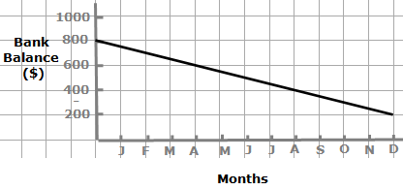

10. **Use the graph to answer the following questions.**

1. What is the rate of change?
2. What does the rate of change mean for the given situation?
3. What is the y-intercept and what does it mean for the given situation?

d) If the graph had the same slope but the y-intercept was 600, what could you conclude?

11. **A car being used for a trip to the Geyser starts with 9 gallons of gasoline, which is a full tank. The car gets one-twenty-fifth $\left(\frac{1}{25}\right)$ of a gallon per mile.**

a.) Write an equation relating the remaining gallons of gas ***y***

to the number of miles ***x***traveled.

b.) Graph your equation. Make sure to label the axes, title your graph, and label/show what your scale is.

c.) How many miles can be traveled before they run out of gas.

12. **Given the following information, write two DIFFERENT forms of the linear equation:** m =  (3, 5)

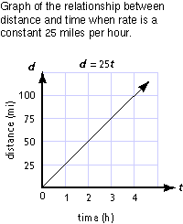1**3. Match the graph with its equivalent table, equation and/or description.**

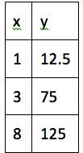 a. b. y = 25x +1 c. As the y value increases by 25, the x value increases by 1.

**14. Find two representations that are… (Answers are only used once.):**

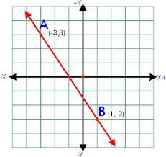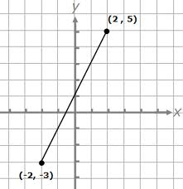 A. $y=-\frac{3}{2} x+2$ C. D.

Parallel: _______ and _______.

|  |  |
| --- | --- |
| x | y |
| -2 | 2 |
| 0 | 3 |
| 2 | 4 |
| 4 | 5 |

B.

Intersecting: _______ and _______.

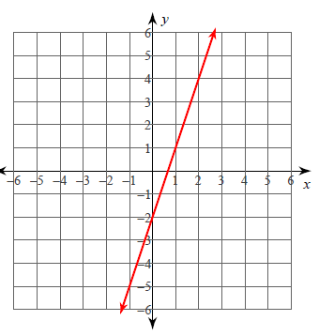15. Write an equation from the graph 16. Find the x and y-intercepts:

in any form: 3x – y = -9