**Station 1**

Solutions:

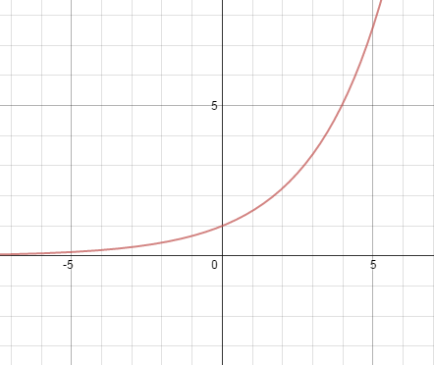1) Any “U” shaped graph 4) Exponential 5) Linear

|  |  |
| --- | --- |
| x | y |
| -4 | 2 |
| -1 | -4 |
| 0 | -6 |
| 2 | -10 |
| 5 | -16 |

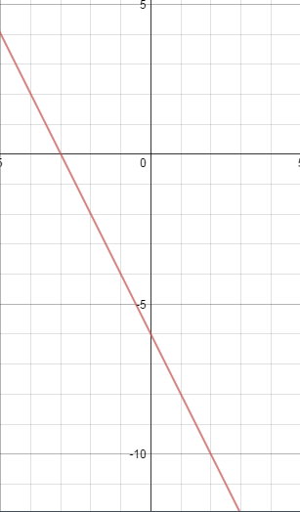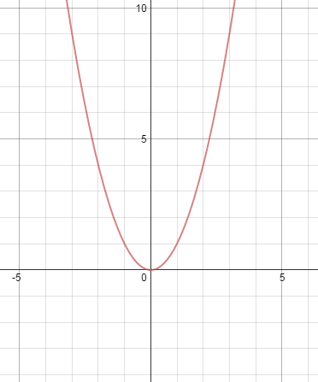

2) Cubic 3) Piecewise

**TABLES-PLOTTING-NAMING**

**Station 2**

Solutions:

1)

a. domain is # of nights

b. range is # of hours of sleep

c. H(5) = 36.25 hours

d. n = 14 nights

2)

a. domain is # of days

b. range is total calories consumed

c. 0 < d < 7 ; [0, 7]

d. 0 < C(d) < 17738 ; [0, 17738]

3)

a. domain is # of minutes

b. range is # of babies born

c. 0 < m < 60 ; [0, 60]

d. 0 < B(m) < 15000 ; [0, 15000]

e. 360,000 babies

**APPLICATION PROBLEMS**

**Station 3**

Solutions:

1. 
2. 
3. [-1, 3] [-7, 9]
4. [0, 10] [0, 3.1]
5. Domain  

Range  

1. Domain  

Range  

1. Domain  

Range  

1. 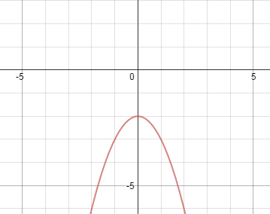Domain  

Range  

CHALLENGE:

**DOMAIN AND RANGE**

**Station 4**

Solutions:

1. Cubic
2. Absolute Value 3) Quadratic

|  |  |
| --- | --- |
| x | y |
| 3 | 5 |
| 4 | 4 |
| 5 | 3 |
| 6 | 2 |
| 7 | 3 |

|  |  |
| --- | --- |
| x | y |
| -10 | -10 |
| -5 | 5 |
| 0 | 10 |
| 5 | 5 |
| 10 | -10 |

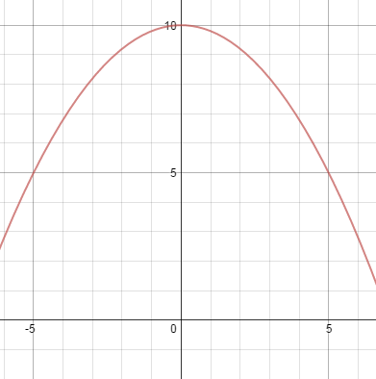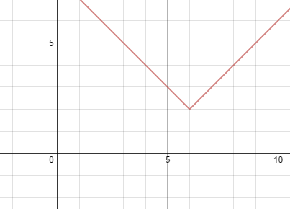

**TABLES-PLOTTING-NAMING**

**Station 5**

**Station 5**

Solutions:

1. g(-7) = -117
2. h(-5) = 4
3. {-31, -13, -4, 14, 32}
4. {-2, 10, 58, 250, 1018}

|  |  |
| --- | --- |
| x | y |
| -3 | -3 |
| 0 | -2 |
| 3 | -1 |
| 6 | 0 |
| 9 | 1 |

CHALLENGE: 1. Quadratic 2. Absolute Value 3. Linear 4. Exponential 5. Linear

**EVALUATING**

**Station 6**

Solutions:

1. Yes, all x-values are unique. Every input has exactly one output. 2) No, the x-values repeat.

1. 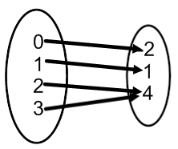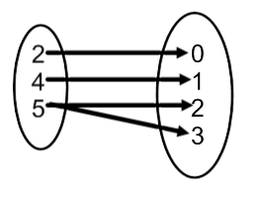No it is not a function 4) Yes it is a function. 5) C

6) “A” should fail the vertical line test and “B” should pass the vertical line test.

7) (-2, 1) OR (-2, -4)

**Is it a function?**