**Algebra I** Name:__________________________

**4.5 Homework - Graphing Linear Inequalities**

**Are the following points solutions to each inequality?**

1.  a. (-1, 2) b. (2, -5)
2.  a. (-1, 4) b. (3, 2)

**For problems 3-7, graph each inequality.**

1. 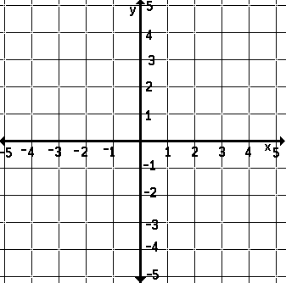 4. 
2.  5. 



1.  7. 



1. Graph the inequality  and complete the table.

