Algebra I

Unit 2 Quiz Stations Review

Station 1 –TABLES – PLOTTING- NAMING

EASY

HARD

1. Draw a graph of a quadratic function.
2. Identify the type of function given f(x) = 6x3 + 5x2 – 4x + 1
3. Identify the type of function displayed in the graph below:

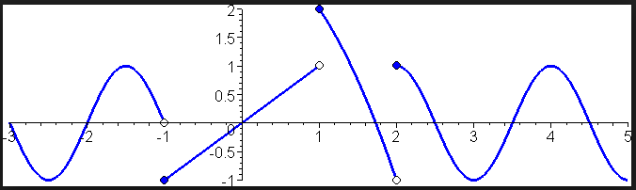

|  |  |
| --- | --- |
| x | f(x) |
| -1 | .67 |
| 0 | 1 |
| 1 | 1.5 |
| 2 | 2.25 |
| 5 | 7.6 |

1. Graph the following points and name the function based on the shape of the graph:
2. Complete the following table, plot the points, and name the function.

|  |  |  |
| --- | --- | --- |
| x | g(x) = -2x - 6 | g(x) |
| -4 |  |  |
| -1 |  |  |
| 0 |  |  |
| 2 |  |  |
| 5 |  |  |

Algebra I

Unit 2 Quiz Stations Review

Station 2 – APPLICATION PROBLEMS

EASY

HARD

1. The average American teenager gets 7.25 hours of sleep per night. The function H(n) = 7.25n represents the total number of hours of sleep a teenager gets H(n) based on the number of nights, n, they have slept.
2. What does the domain represent? ___________________
3. What does the range represent? ____________________
4. In 5 nights, how much total sleep does a teenager get? _______________
5. How many nights does it take for a teenager to get 101.5 hours of sleep? ____________________
6. The average American consumes 2,534 calories per day. The function C(d) = 2534d represents the total number of calories consumed ***C(d)*** given the number of days ***d***.
7. What does the domain represent? ___________________
8. What does the range represent? ____________________
9. If you were keeping track of your calories for one week, what would be the domain of the function as an inequality and interval? ______________________
10. What would the range be as an inequality and an interval given that same time frame? _______________________
11. An average of 250 babies are born around the world each minute. The function B(m) = 250m represents the total number of babies born B(m) given the number of minutes m.
12. What does the domain represent? ___________________
13. What does the range represent? ____________________
14. If you were keeping track of how many babies were born in one hour, what would the domain of the situation be as an inequality and an interval? ______________________
15. What would the range be as an inequality and an interval given that same time frame? _______________________
16. On average, how many babies are born per day around the world?

Algebra I

Unit 2 Quiz Stations Review

Station 3 – DOMAIN AND RANGE

EASY

HARD

|  |  |
| --- | --- |
| 1) Change the following inequality to interval notation for the domain: -< x < 7 | 2) Change the following interval to inequality notation for the range: [-3, ) |

Directions: Complete the domain and range of the graphs below.

|  |  |
| --- | --- |
| 3) Domain: [-1, ___ Range: ___, 9] | 4) Domain: ___ , 10]Range: [0,3.1] |

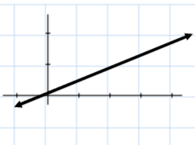Directions: Write the domain and range for each of the graphs below. Write each answer as an inequality and as an interval.

|  |  |
| --- | --- |
| 5) | 6) |
| 7) | 8) |

CHALLENGE: Draw a graph of a quadratic function with the domain (-,) and range (-, -2].

Algebra I

Unit 2 Quiz Stations Review

Station 4 –TABLES – PLOTTING-NAMING

EASY

HARD

|  |  |
| --- | --- |
| x | f(x) |
| -3 | 9 |
| -2 | 0 |
| -1 | -1 |
| 0 | 0 |
| 1 | -3 |

1. Use the following table to make a graph and identify the type of function.

|  |  |  |
| --- | --- | --- |
| x | g(x) = | x – 6| + 2 | g(x) |
| 3 |  |  |
| 4 |  |  |
| 5 |  |  |
| 6 |  |  |
| 7 |  |  |

1. Complete the following table, graph, & identify the function.

|  |  |  |
| --- | --- | --- |
| x | h(x) = -0.2x2 + 10 | h(x) |
| -10 |  |  |
| -5 |  |  |
| 0 |  |  |
| 5 |  |  |
| 10 |  |  |

1. Complete the following table, graph, & identify the function.

Algebra I

Unit 2 Quiz Stations Review

Station 5 – EVALUATING

EASY

HARD

1. Evaluate g(-7) for the function g(x) = -3x2 – 4x + 2.
2. Evaluate h(-5) for the function h(x) = |x + 1|.
3. What is the range of the function f(x) = 9x – 4 given the domain {-3, -1, 0, 2, 4}?
4. What is the range of the function d(t) = .25t – 6 given the domain {-5, -4, -3, -2 , -1}?
5. Complete the following table:

|  |  |  |
| --- | --- | --- |
| x | f(x) = 1/3x – 2 | f(x) |
| -3 |  |  |
| 0 |  |  |
| 3 |  |  |
| 6 |  |  |
| 9 |  |  |

CHALLENGE: Identify the name of each function for examples #1-5 at this station.

Algebra I

Unit 2 Quiz Stations Review

Station 6 – IS IT A FUNCTION?

EASY

HARD

1. Does the following relation display a function? Explain.

{(4, -1), (-5, 2), (-1, 6), (3, 4)}

1. Does the following relation display a function? Explain.

{(1, -7), (2, 2), (-1, 9), (1, 4)}

1. Create a mapping diagram to determine if the following relation is a function {(4, 1), (2, 0), (5, 3), (5, 2)}.
2. Create a mapping diagram to determine if the following relation is a function {(1, 1), (2, 4), (3, 4), (0, -2)}.
3. Use the vertical line test to determine which of the following is/are functions. Choose all that apply.

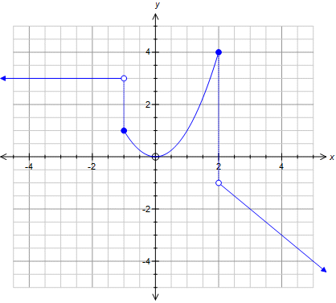 A B C

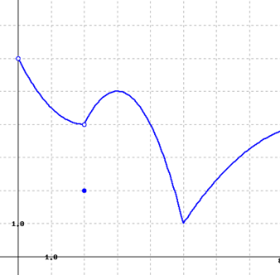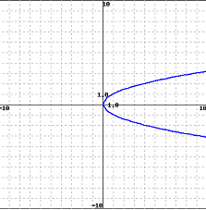

1. Draw a picture of a graph that would not be considered a function and label it “A”. Draw a picture of a graph that would be considered a function and label it “B”. Explain why you drew each picture the way you did.
2. 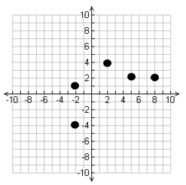Which point could be removed from the graph in order to create a function?