Algebra I

Mid Unit 1 Test Stations Review

Station 1 – IDENTITY - NO SOLUTION – LITERAL EQUATIONS

EASY

HARD

**Directions:** *Solve for the missing variable.*

1. 
2. 

**Directions:** *Solve the equations for the indicated variable.*

1.  for y
2.  for h
3.  for y

CHALLENGE: Solve 

Algebra I

Mid Unit 1 Test Stations Review

Station 2 – PERIMETER – COMBINE LIKE TERMS

EASY

HARD

Solve for the variable.

1. 
2. 
3. The perimeter of the following rectangle is 86 inches. What is

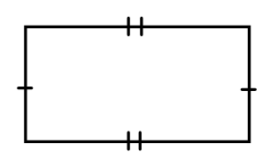

5x+1

5x+1

2x

2x

the value of x?

**P = 2L + 2W**

1. The perimeter of the following rectangle is 20 feet. What is

3x - 2



x

the value of x?

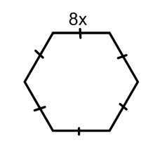CHALLENGE: If the perimeter of the following figure is 48cm, what is the value of x?

Algebra I

Mid Unit 1 Test Stations Review

Station 3 – VERTICAL ANGLES - SOLVING

EASY

HARD

**Directions:** *Solve for the variable.*

1. 
2. 

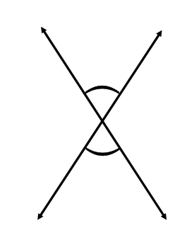

(9x + 1)o

(15x - 35)o

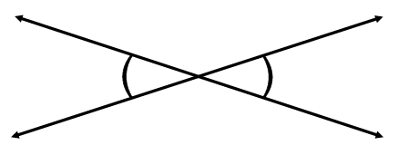Hint: set the two expressions equal to each other.

(6x + 50)o

(18x - 10)o

Hint: set the two expressions equal to each other.

Algebra I

Mid Unit 1 Test Stations Review

Station 4 – PROPORTIONS – PROPORTION APPLICATION

EASY

HARD

**Directions:** *Solve the following proportions for the variable.*

1. 
2. 
3. A 15 ft flagpole casts a shadow that is 8 ft long. A man

standing nearby casts a shadow that is 3.2 ft long. How tall is

the man? (Hint: draw a picture)

1. If a recipe calls for 2 cups of sugar to make 40 cookies, how many cups of sugar would be needed to make 100 cookies?

CHALLENGE: An 8ft shadow is casts by a 5 ft woman. If an 11 ft tree is nearby, how long would its shadow be?

Algebra I

Mid Unit 1 Test Stations Review

Station 5 – FRACTIONS

EASY

HARD

**Directions:** *Solve for the variable.*

1. 
2. 
3. 
4. 
5. 

Algebra I

Mid Unit 1 Test Stations Review

Station 6 – WORD PROBLEMS

EASY

HARD

**Directions:** *Define a variable, write and equation, and solve.*

*Make sure to show your work!*

1. An admission ticket for the Brookfield Zoo costs $15 per person.

Parking at the zoo costs $8. If your family spent $98 to get into

the zoo, how many admission tickets were purchased?

1. Shirts are $8 at Old Navy and you have a coupon for $5 off your

total purchase. If you have a budget of $35, what is the total number of shirts that you could buy?

1. You and your family decide to go to a Bears game. Each ticket

costs $165. If you spend $30 dollars to park and your total for

the day is $690, how many tickets were purchased for the

football game?

CHALLENGE: Each family member needs a plane ticket that costs

$225 and $20 per ticket for travelers insurance. If the family

spends $735, how many people are in the family?