Pg 553 #12, 13

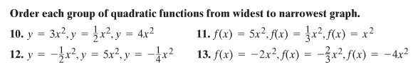

Pg 561 #28, 30
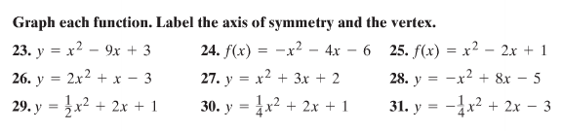

Pg 563 #46-48
